济水一中2015-2016学年下 期中考试 七 年级 英语 试卷
学校 班级 准考证号 考场 座号

…………………………………………………装……………………………订……………………………线…………………………………………………
…………………………………………………答……………………………题……………………………线…………………………………………………
时间 100 分钟 分值 120 分

一、听力理解（20分）
第一节：听句子，选择最佳应答语。读两遍（共5分）
1. A. At school. B. Yes, I do . C. Yes, I can
2. A. No, I’m not B. walking C. May 1st
3. A. Friday B. English C. Soccer
4. A. In Beijing B. The music club C. July
5. A. Yes, I do B. At 6:00 C. Because it’s interesting
第二节：听下面5段对话，每段对话后有一个小题。根据其内容选择最佳答案。读两遍(5分)
6. What can Jim do ?
A. He can sing . B. She can swim. C. He can swim ..
7.What does he want to be?
A. A student B. An actor. C. A teacher .
8. What time does Mary get up in the morning ?
A. At six . B. At six thirty . C. At seven .
9. Do they want to go to the library?
A. Yes, Tony does. B. Yes, they do. C. No, they don’t
10. Where do pandas live?
A. Africa . B. In China. C. In other countries
第三节：听下面两段对话，每段对话后有几个小题。根据其内容选择最佳答案。读两遍。（5分）
听下面一段对话，回答第11到12两个小题。
11.Where does Jack want to go?
A. A library. B. A post office. C. A bus station.
12.How long does it take to get there?
A. 10 minutes. B. 20 minutes C. 30 minutes.
听下面一段对话，回答第13至15三个小题。
13. How many lessons does Jack have on Monday?
A. Five B. Six C. Seven
14. What time do classes finish in the afternoon?
A. 4:30 B. 5:00 C. 5:30
15. What does Ann do at 9:30 at night?
A. She watches TV. B. She does her homework.
C. She goes to bed.
第四节：听短文，按照你所听到的先后顺序将下面的图片排序。读两遍。（5分）
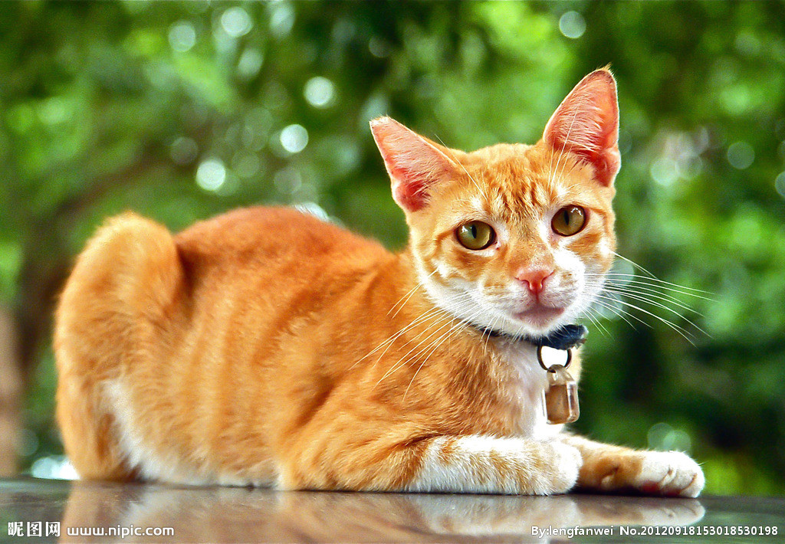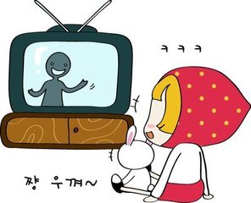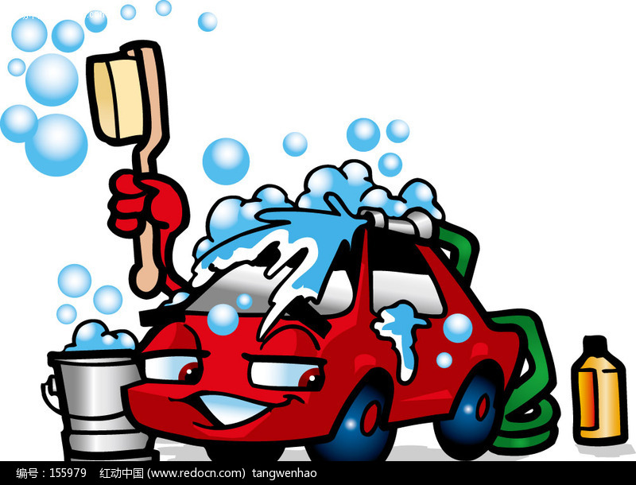
A B C D E
二、单项选择（15分）
( )21、He often plays________ basketball for________hour.
A、/; an B、the;an C、a; a D、/; a
( )22、—When you’re hungry, where can you get something to eat?
—______ _.
A、In a pool B、In a restaurant C、In a garden D、In a library
( )23、—________is it from your home to school?
—It's about two kilometers.
A．How far B．How long C．How D. How much
( )24、My work is interesting but ______ dangerous.
A a kind B kinds of C. kind of D. kind
( )25、Look! Emma is_______ her bedroom. Her room is always_________.
A、clean; clean B、clean; cleaning
C、cleaning; clean D、cleaning; cleaning
( )26、—Mr Black, can I play with Tom?
—I’m sorry , he_________play with you now.He _________his homework.
A、can; is doing B、can’t; is doing C、can’t; does D、can; does
( )27、My parents always exercise ________ six ________ the morning.
A．at，on B. on，at C. in，at D. at，in
( )28、_______ in the classroom.
A. Don’t run B. Can’t run C. Not run D. Doesn’t run
( )29、What’s Jim doing over there? He’s_______ his friends.
A、talking B、talking with C、talks D、talk
( )30、People are really_______on the beach in summer.
A、relaxed B、relaxing C、boring D、bored
( )31、_______sleeps during the day but at night he gets up and eats food.
A、A panda B、A dog C、A koala D、A giraffe
( )32、It takes_______ ten minutes _______on foot
A、his; to get to school B、him; to get to school
C、his; going to school D、him; going to school
( )33、I have ________ homework to do and Judie has ________ books to read.
A．too much，too many B．too many，too many
C．too many，too much D．too much，too much
( )34、 His _____ are very _____ to us. We all like them.
A. friendly; friendly B. friends; friendly
C. friend; friendly D. friendly; friends
( )35、The teacher ______ me to _______ it in English.
A. tells, say B. says, tell C. talks, say D. speaks, tell
三、完形填空（10分）
Mr. Smith 36_____ from London. Now he is in China. He is 37______ . He teaches 38_______ a middle school. He works very hard. His students like 39_____ very much. He can 40_____ a little Chinese . His students often teaches him Chinese on Sundays. Mr. Smith likes playing soccer. He often plays 41____ with his students.
Mr. Smith 42____ a son. His name is Jack. He is a student. He studies in a middle school. He likes 43____ TV. It's 7 :00 p.m. now. Mr. Smith 44____a letter to his friend. Jack is 45_____ a newspaper. His mother is cleaning the room. They're busy.
( )36.A.am B. is C. are D. be
( )37.A. a teacher B. an actor C. a reporter D. a doctor
( )38.A. on B. in C. of D. from
( )39.A. he B. him C. she D. her
( )40.A. say B. speak C. talk D. tell
( )41.A. baseball B. soccer C. ping pong D. basketball
( )42.A. has B. have C. there is D. there are
( )43. A. watch B. watches C. watching D. watched
( )44.A. write B. writes C. is writing D. are writing
( )45.A. looking B. seeing C. reading D. watching
四、阅读理解 (40分)
A.
It' s Sunday morning. There are many people in the park, some boys are playing basketball. There are some girls under a big tree. They' re singing and dancing. What are those women doing? They are drinking tea. Look at the woman in a blue coat. Who' s she? She' s my mother. She is talking to Edward. Edward is her student. He is a good student. He studies hard . He' s good at all the subjects. And he' s friendly to all his teachers and his friends.
( ) 46. The boys are _______
A. singing B. playing basketball C. dancing D. drinking
( ) 47. My mother is ______.
A. a teacher B. an office C. a doctor D. a woman
( ) 48. Edward is in_______ .
A. my home B. the classroom C. the zoo D. the park
( ) 49. —— Who' s under a big tree?
—— ___________________. .
A. Some people. B. Some women. C. Some girls. D. Some boys.
( ) 50.—— What color is my mother' s coat?
——It's ____________________.
A. blue B. white C. red D. yellow
B
In most English homes ,people eat four meals a day. They have breakfast at any time from seven to nine in the morning. They eat porridge(粥) eggs or bread and drink tea or coffee for breakfast. Lunch comes at one o’clock. Afternoon tea is from four to five in the afternoon and dinner is about half past seven. First they have soup, then they have meat or fish with vegetables. After they eat some other things, like bananas, apples or oranges. But not all English people eat like that. Some of them have their dinner in the middle of the day. Their meals are breakfast, dinner, tea and supper and all these meals are very simple.
( )51. Many English people have ______ meals a day.
A. two B. three C. four D. five
( )52. People may have ______ for their breakfast according to the passage.
A. tea and eggs B. hamburgers and tea
C. coffee and salad D. eggs and fish
( )53. People have lunch at _______.
A. any time B. nine C. five D. one
( )54. People don’t have _____ for their dinner.
A. bananas and apples B. soup and meat C. meat and fish D. porridge
( )55. Most Englishmen have dinner _____ .
A. at one B. at any time
C. at noon D. in the evening

C
Wanted: An English Teacher
Do you like kids? Are you outgoing(开朗的)? Do you have over three years’ experience(经验) as an English teacher? Do you have free time on Saturday and Sunday? I need a woman teacher for my daughter. She is twelve .She loves English but she is not good at English.
You will:
1. Teach from 3:00 to 6:00 p.m..
2. Play with my daughter.
3. Tell her stories in English.
Our address: Beihai Road, Garden District.
If you want to know more information(信息), please call Mrs. Yang at 82569876.
根据上面的招聘广告，选择合适的选项
( )56. Mrs. Yang wants ________ for her daughter.
A. a babysitter(保姆) B. a good cook
C. an English teacher D. a math tutor
( )57. If you want to work for Mrs. Yang, you must teach the daughter for _______ on weekends.
- three hours B. six hours C. a day D. A whole afternoon
( )58. If you want to be the teacher, you need to ________.
①be beautiful ②have over three years’ teaching experience
③have time on weekends ④ be a woman
A. ①② B. ②③ C. ①②③ D. ②③(4)
( )59. If you want to know more about the job, what can you do?
A. Write an email to Mrs Yang.
B. Make a phone call to Mrs Yang.
C. Go to Mrs Yang’s house.
D. Write a letter to Mrs. Yang.
( )60.What do you know about Mrs. Yang’s daughter
A. She is good at English. B. She is eleven years old.
C. She is busy on the weekend. D.She loves English.

D.
The Browns are the Smiths’ neighbours. Mr Brown’s name is John. But when his neighbours talk about him, they all call him” Mr Going-to-go”. Do you know why? Mr Brown says he is going to do something, but he never does it. Every Saturday Mr Brown goes to the Smiths’ back door and talks to Mr Smith. He always says he is going to do something. ”I’m going to clean my house today,” he says, or “I’m going to wash my car tomorrow ,” or “ These trees in front of my house are too big, so I’m going to cut them down next week.”
Mr Smith usually says “Are you John?” He knows his neighbor is not going to clean his house, or wash his car, or cut down any trees. Then he says, “Well, excuse me. John, I’m going to do some work in the house.” And he does . Mr and Mrs Smith often say to their only child Dick. “ A re you going to do something? Then do it! Don’t be another Mr. Going-to-do!”
( )61. What’s the relationship(关系) between Mr. Brown and Mr. Smith?
A. They are brothers. B. They are neighbours.
C. They are father and son D. They are teacher and student.
( )62. Why do people call Mr Brown “Mr. Going-to- do”?
A. Because he talks a lot and does a lot.
B. Because he often talks much before he starts his work.
C. Because he always says to do something, but never does it.
D. Because he usually needs help when he is going to do something.
( )63. When will John cut the trees down?
A. Today. B. Tomorrow.C. Next week. D. We don’t know.
( )64. What does Mr. Smith think of John’s talks?
A. Pleasant. B. interesting. C. Worrying. D. Happy.
( )65. Who does Mr. Smith ask Dick not to learn from?
A. Mr. Brown. B. Mrs. Brown. C. Mrs. Smith D. Himself.
五、选词应用（10分）
child clean after shop take teach early read then with

Mrs. Dean is Mike’s aunt. She is a 66 . She works at No. 2 Middle School in Beijing. She has two 67 . Their names are Sandy and Peter. Sandy is a nice girl. Every morning she gets up 68 . First she helps Mrs. Dean 69 the house. Then she 70 books in her bedroom. Sometimes she gives food to her bird Polly. 71 that she goes to school with her brother Peter. When school is over, she usually waits for Peter at the school gate. 72 they go home together. On weekends, she sometimes goes 73 with her mother. And sometimes she goes swimming 74 Peter. Where’s she now? Look! She is 75 photos of Peter with her new camera. Hmm, the two children look very happy.

六、补全对话(10分)

A: Hello, This is Jim.
B: Linda? Hi! 76.____________________________________ ?
A: I’m from Boston!
B: Wow, 77._______________________________?
A:I like pandas.What about you?
B: I like pandas too. 78._____________________________?
A: I’m doing my homework. I’m studying in a school of Boston.
B: Really? How do you get to school?
A:79._______________________________ . The school is not far from my house. And the bus ride is exciting.
B: Oh,80._________________________________ ?
A: I get up at 8:00. Our class begins at 9:00 in the morning.
B: Sounds like you are having good time there. Happy every day!
A: Thanks. Call you next time.
B: OK. Bye.

七、书面表达(15分)

假设现在是星期日上午8：30，天气晴朗，暖洋洋的。Dave和他的同伴们正在公园玩的很开心，请根据下面提供的信息写一下他们的活动。60词左右,题目自定。

Name Activity Place

Dave 、Jim and Mike play soccer in a park

Linda play the violin under the tree

Judie read a book near a tree

Tom and Ken swim in a pool
学校 班级 准考证号 考场 座号

…………………………………………………装……………………………订……………………………线…………………………………………………
…………………………………………………答……………………………题……………………………线…………………………………………………

学校 班级 准考证号 考场 座号

…………………………………………………装……………………………订……………………………线…………………………………………………
学校 班级 准考证号 考场 座号

…………………………………………………装……………………………订……………………………线…………………………………………………
…………………………………………………答……………………………题……………………………线…………………………………………………
…………………………………………………答……………………………题……………………………线…………………………………………………
座号:

